A FOREST FIRE IDENTIFICATION METHOD FOR UNMANNED AERIAL VEHICLE MONITORING VIDEO IMAGES

ABSTRACT :
An automatic forest fire monitoring system based on UAV(unmanned aerial vehicle)-acquired video images was studied in this paper.This novel method was proposed to address current problems in forest fire information monitoring practices such as poor real-time performance and low efficiency.Besides, it aims to realize the dynamic monitoring of forest fires in wild environment. In this paper, a forest fire monitoring method based on active analysis of UAV-acquired video image features is proposed to automatically detect and identify the occurrence of forest fires. The motion detection method based on dense optical flow and background modeling method were used to extract the motion regions for eliminating the influence of image background. By using wavelet energy feature and texture feature, 9 video images acquired by multi-rotor UAV on forest fire monitoring were selected as sample images(8 images for experiment and 1 image for contrast purpose). The mean values and standard deviations of the gray level co-occurrence matrix eigenvalues(angular second moment, entropy moment and reciprocal differential moment) were calculated as the discriminant basis for identifying forest fires. The experimental results showed that the proposed algorithm can effectively identify the forest fire,which provides a theoretical guarantee for the forest resources protection.

EXISTING SYSTEM :
Traditional monitoring methods can not collect forest fire video information in real time and effectively. At present, due to the characteristics of heavy load, long duration and strong wind resistance, eight-rotor unmanned aerial vehicle is widely used in forest fire monitoring field.
The eight-rotor aircraft is driven by eight independent motors in which the adjacent motors rotate in the opposite direction to eliminate torque caused by motor rotation. Theaircraft can control six freedom degrees of aircraft by controlling the rotational speed of eight rotors.
DISADVANTAGES OF EXISTING SYSTEM :
1) Less accuracy
2)low Efficiency

PROPOSED SYSTEM :
Traditional video-based forest fire monitoring equipments are usually fixed cameras that are deployed on the top of a mountain[17], and the background of captured video usually remains static, which is only applicable to long-distance and large-field forest fire monitoring. In addition, there are influential factors such as foggy in videos captured during morning.Traditional methods lack the ability to deal with this situation. This paper proposed a novel forest fire detection method based on image active analysis to address these limitations.

ADVANTAGES OF PROPOSED SYSTEM :
1) High accuracy
2)High efficiency

SYSTEM ARCHITECTURE :

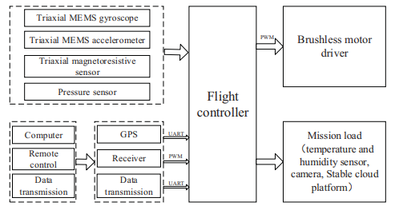

HARDWARE & SOFTWARE REQUIREMENTS:
HARD REQUIRMENTS :
- System : i3 or above
- Ram : 4GB Ram. \
- Hard disk : 40GB
SOFTWARE REQUIRMENTS :
- Operating system : Windows
- Coding Language : python

